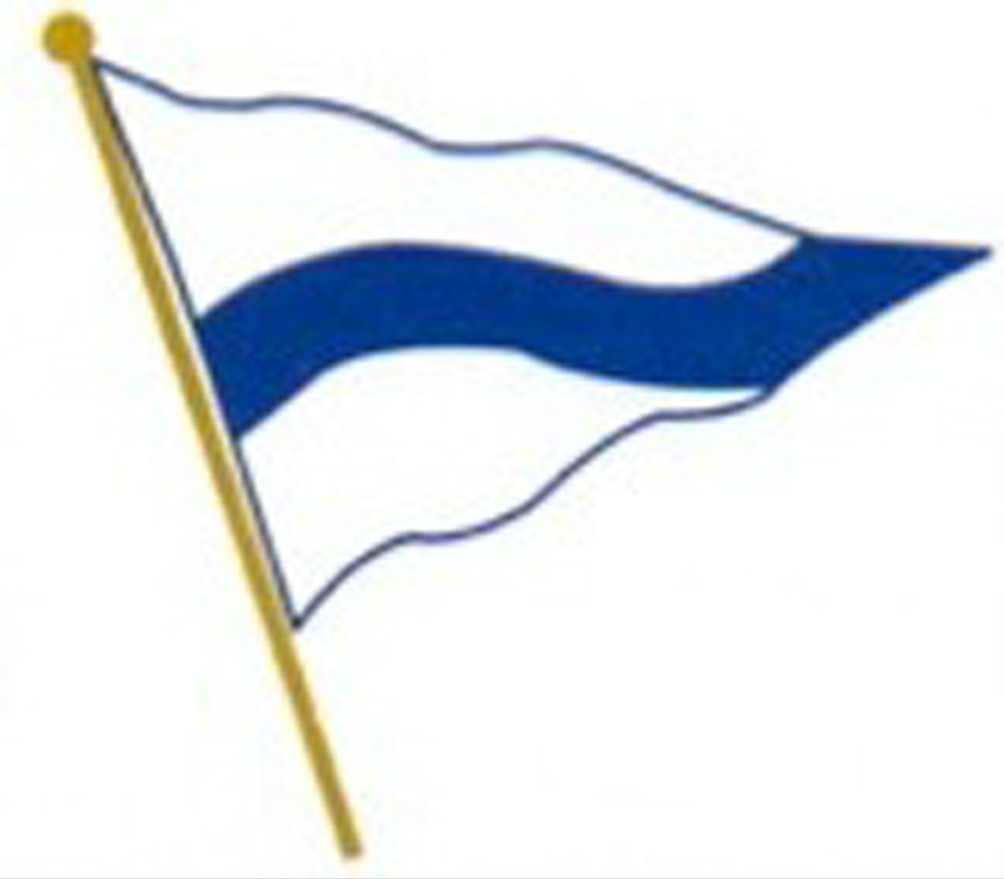

SAF Station Meeting Minutes for November 6, 2024

By Mary Lovely for Richard Schaper, Secretary

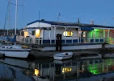

The November meeting of the San Francisco Station of the Cruising Club of America was held at the Sausalito Cruising Club located in Sausalito, CA.

THOSE IN ATTENDANCE:

Zia Ahari, Skip Allan, Clark Beek, Don Bekins, Bill and Janice Belmont, Rowena Carlson, Bill and Sandy Edinger, Dick Enersen, Peter English, Doug and Anne Finley, Peter Fulliger, Wyman and Gay Harris, Bob and Liz Hart, Chuck and Susan Hawley, Tom and Wendy Hutton, Mike Johnson, Stafford Keegin, Terry Klaus, Micheal Leal, Bill and Joan Mittendorf, Steve Mason and Ginger Souders-Mason, Bruce Munro, Christopher Parkman, Synthia Petroka, Michael and Susan Proudfoot, Jim Quanci and Mary Lovely, Robby and Dolores Robinson, and Moe Roddy, Guests: Linda Moore, guest of Skip Allen and Chuck and Susan Hawley, Andy Egler, guest of Dick Bekins, Dave Pressley, guest of Bill Eddinger, and Scott Wall, guest of Michael Lael.

Our guest speaker was Bill Edinger with additional comments and photography by Sandy,

REAR COMMODORE’S REPORT

R/C Hawley began the meeting by welcoming guests.

He discussed the Fall meeting held at Annapolis Yacht Club. Several members of the SAF station attended: Chuck Hawley, Moe Roddy, Rowena Carlson, Michael Morazedah and Noelle Leca. Some of the takeaway highlights included:

1. The 2024 cruises went well except for the Down East cruise one where many of the people on the mother ship contracted Covid. Bruce Munro happened to be on the yacht.
2. Many cruises are planned for 2025 including the Trans-Atlantic cruise followed by the Western Islands in Scotland. Several members of the SAF station will be joining the Scotland cruise.
3. The 2025 fall meeting will take place on September 17 in the Pacific Northwest preceded by a cruise.
4. The 2025 Annual Meeting will be in New York March 6 – 8, 2025.
5. There is a cruising guide on line relates information on how to run a national CCA cruise.
6. Boat loss in the Bermuda Race report will be coming out soon.
7. The Safety Notes on Life Jackets will be attached to the email and printed in Waypoints.

TREASURER’S REPORT

Synthia reported that we currently up by $4,000. The dues push resulted in 95% participatio

CRUISING REPORT

The Cruising group will put out a survey about where the membership would like to go. Chuck and Michael M. will set up the questionnaire. Bill Mittendorf is the local cruising chair.

MEMBERSHIP REPORT

Moe Roddy suggested that we ask members of our clubs that we know. She conducted a Safety for cruising couples seminar and there may be potential members there.

ENVIRONMENT OF THE SEA REPORT

Rowena Carlson announced that she will be stepping down from her national position heading up Environment of the Sea. There is an article in Yachting World featuring Mary Crowley and Ocean cleaning. Rowena reminded the group to not use single use plastics.

MEDICAL REPORT

Dr. Zia Ahari stated that Covid Is coming back in many different ways. He suggested to wear masks when shopping, wash hands and keep distance.

PROGRAM CHAIR REPORT

The next meeting, the Holiday Event, will be held on THURSDAY, December 5, 2024 at St. Francis Yacht Club.

NOMINATING COMMITTEE

The nominating committee has met and has recommended the following officers for 2025:

Rear Commodore, Chuck Hawley

Treasurer, Synthia Petroka

Secretary, Mary Lovely

SAFETY MOMENT

The Safety Moment for November is an attached pdf. The topic is What is a Life Jacket Supposed to do?

FEATURED SPEAKER

The station members were treated to a fascinating presentation on Bill and Sandy Edinger’s 2020 trip in South India and focused on their three-day river delta cruise just south of Kochi. The colors and contrasts of India came through in the brilliant photos. They spoke of the friendliness of the people and uniqueness of the boats.

Respectfully submitted,

Mary Lovely